**Georgia Brooks University** How To Access Student Balance/Payments

1. Visit gbuniversity.org  
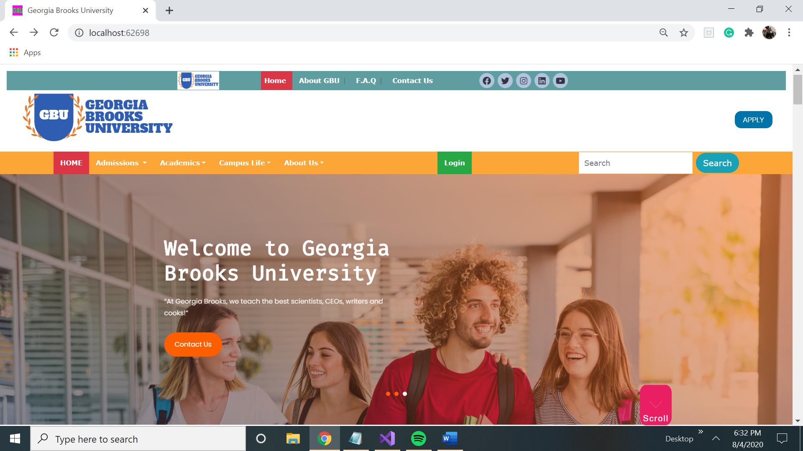  
  
2. Click on the “Login’ button.  
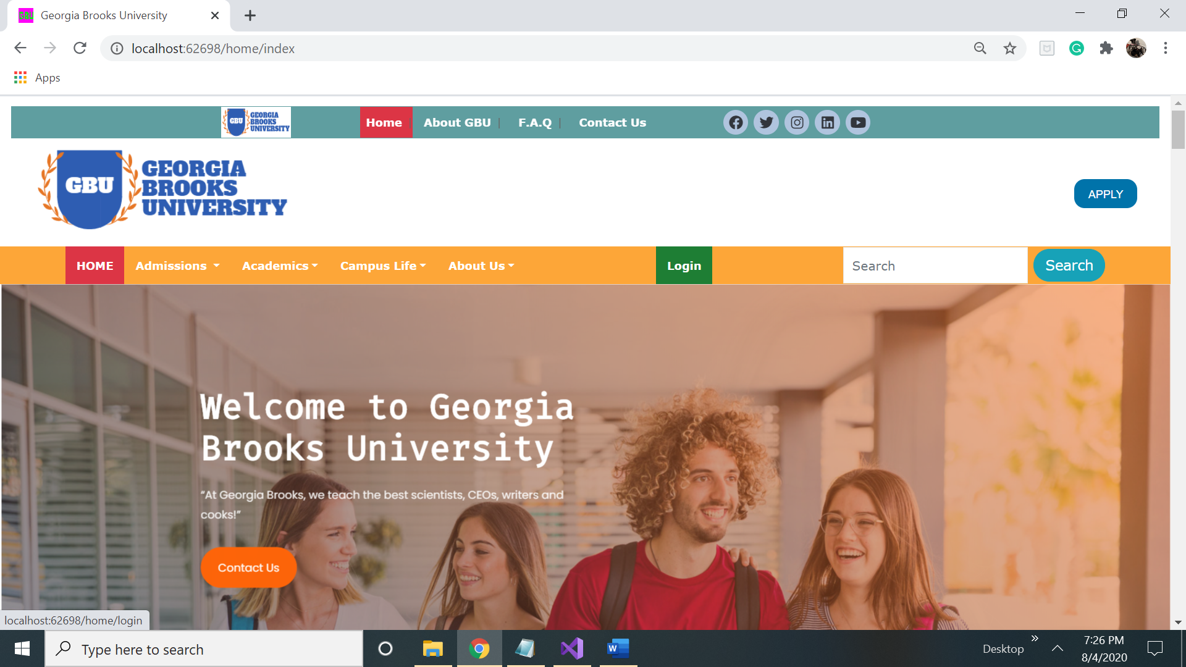  
  
3. Enter your Username & Password to login to your student account.  
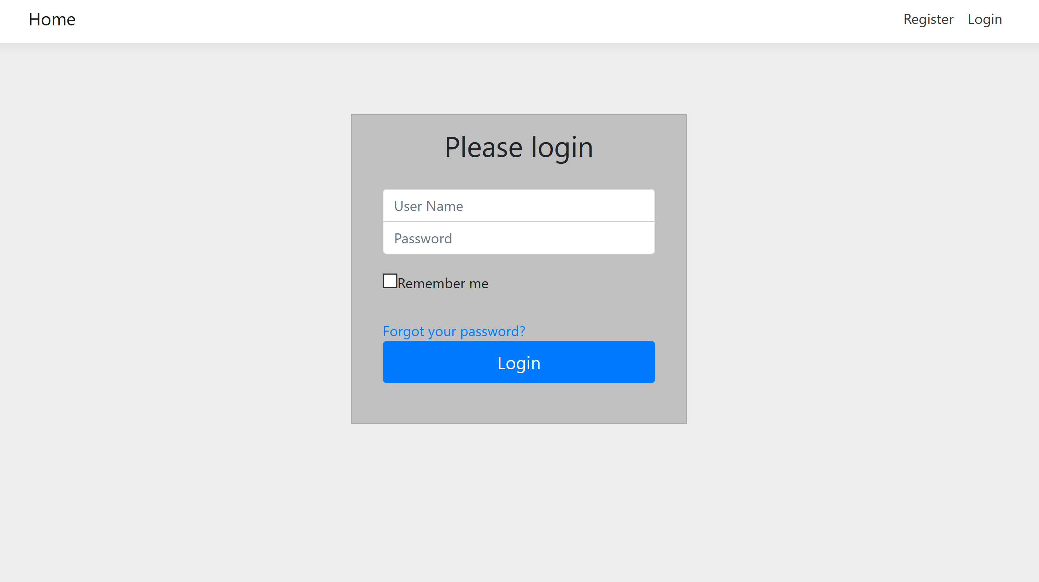  
  
4. View the Upcoming Events & Activities and your current balance at the middle of the Student Account Page.  
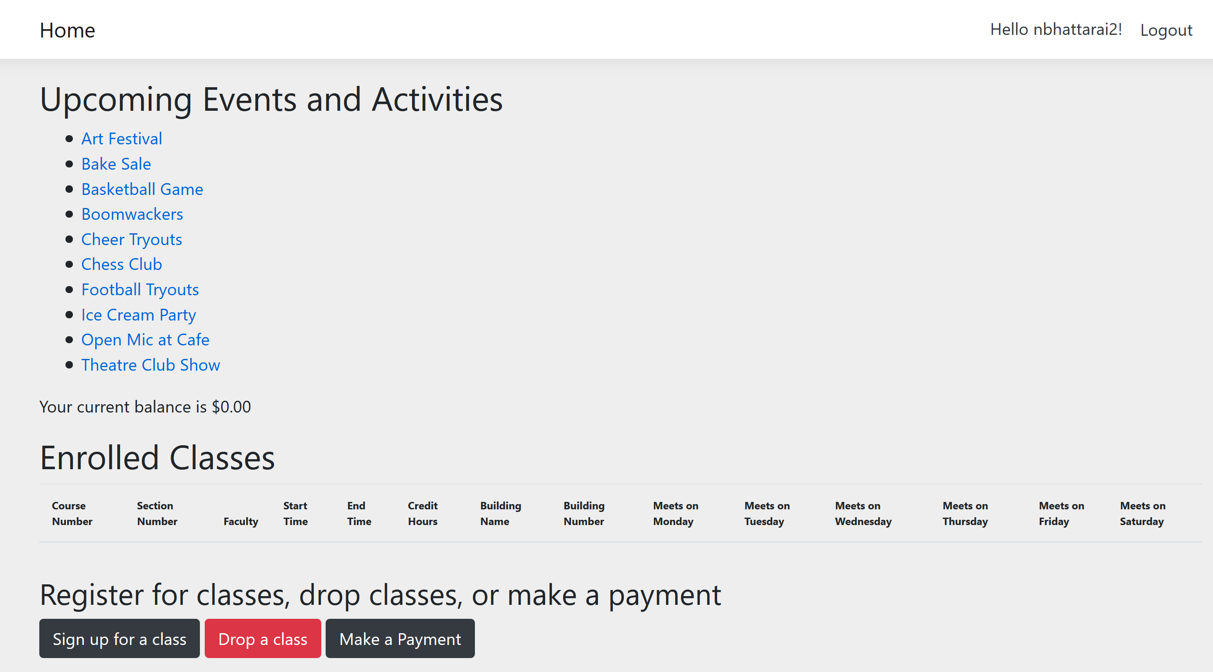  
  
  
5.Register for classes if you haven’t

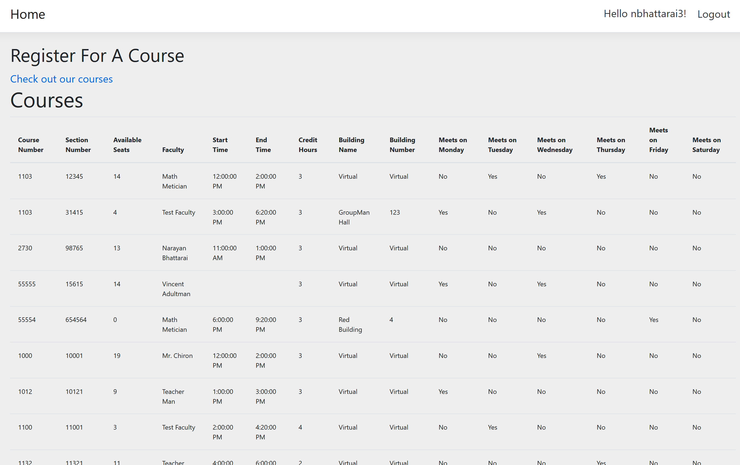  
6. Click on the Make a Payment to make payment!  


7.

Make sure to fill all the fields. If you make mistake, you will get an error message and you should be able to change just that and click on Pay. If you want to restart and empty all the fields, just click the refresh button.

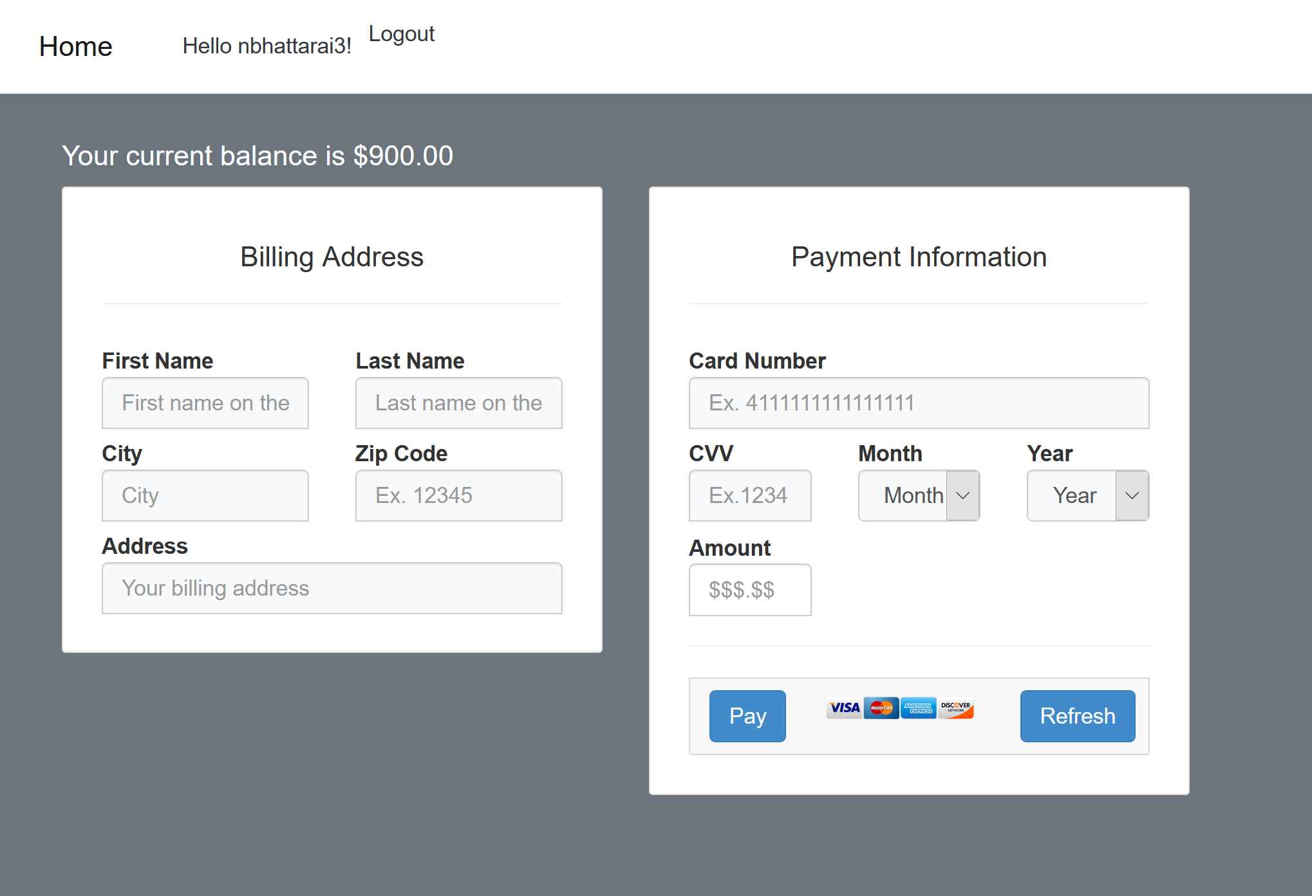

8.

Once you are done paying and the payment is successful, you will get the following message. If you are done, just click on home button to go to main page

